Part A:

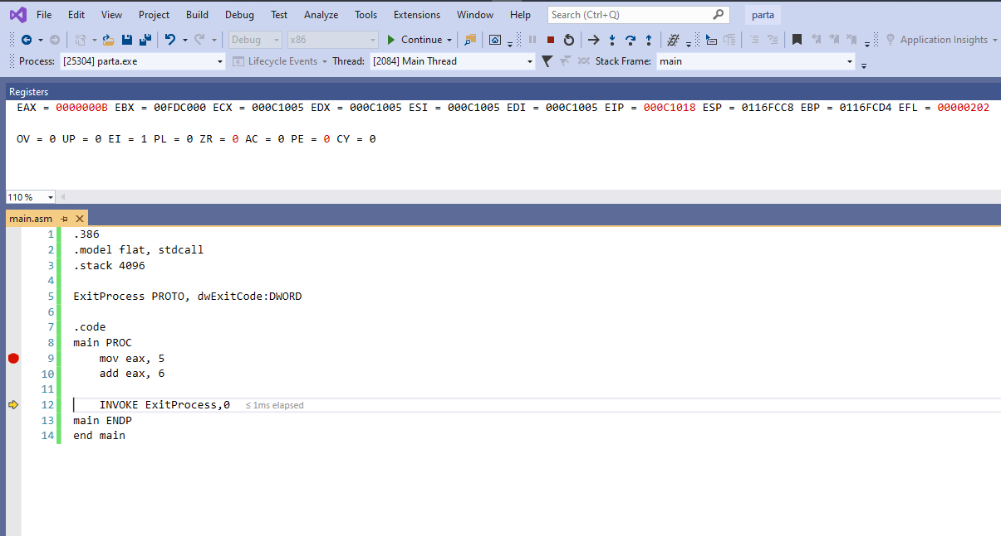

Problem 1

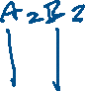

Problem 2

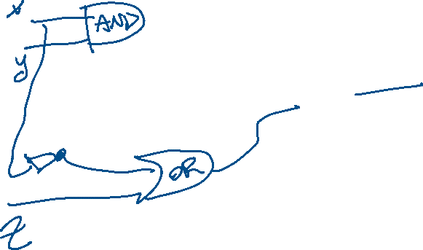

eax is 0 to 31 bits, so 32 bits availability in total. Thus we can separate each section as 8 bits,

|  |  |  |  |
| --- | --- | --- | --- |
| 12h | 78h | 45h | 69h |

